AWS infra via Terraform:

- EC2
Steps:
  - Create a folder named awsec2.
  - Create a file called main.tf inside the awsec2 folder.
  - Configure the AWS provider:
Go to the Terraform Registry → AWS Provider → "Use Provider" → copy the example code and paste it into main.tf.
  - Specify the region inside the provider block.
  - Create a new resource for EC2 using ( resources “aws_instance” “myserver”)
  - In the resource block, provide the AMI ID:
Go to AWS Console → EC2 → Launch Instance → select an OS → copy the AMI ID.
  - Set the instance type (e.g., t3.micro).
  - Add tags to give a name to your EC2 instance.
  - In the terminal, navigate to the awsec2 folder.
  - Initialize Terraform: terraform init
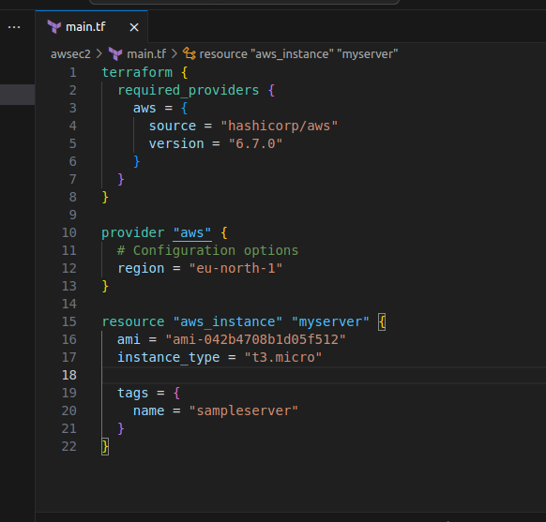

  - Run terraform plan – preview the changes
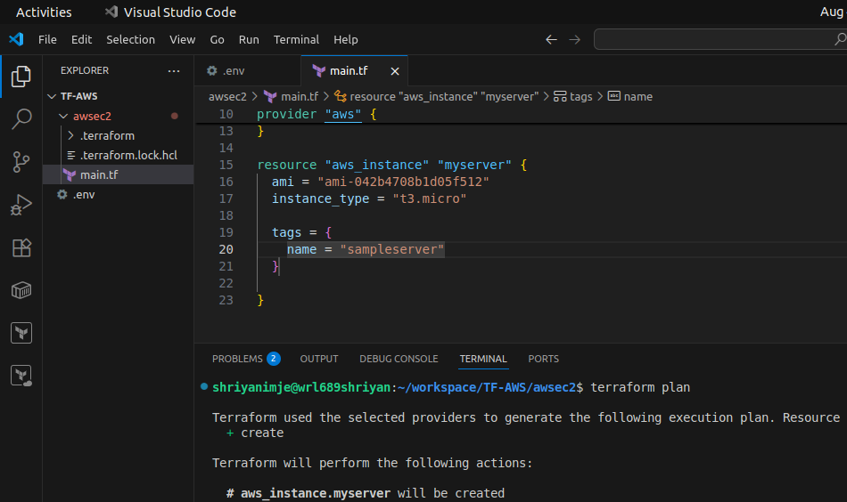

  - Run terraform apply – to make changes to the infrastructure
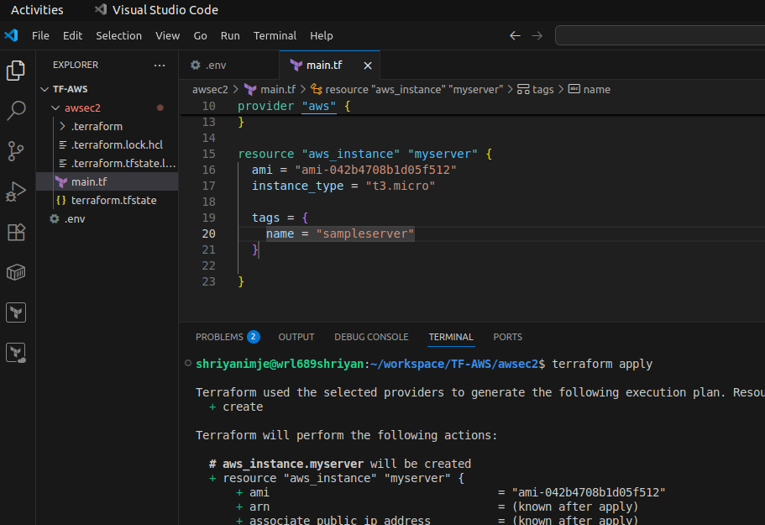

  - It will create an ec2 instance with SampleServer name

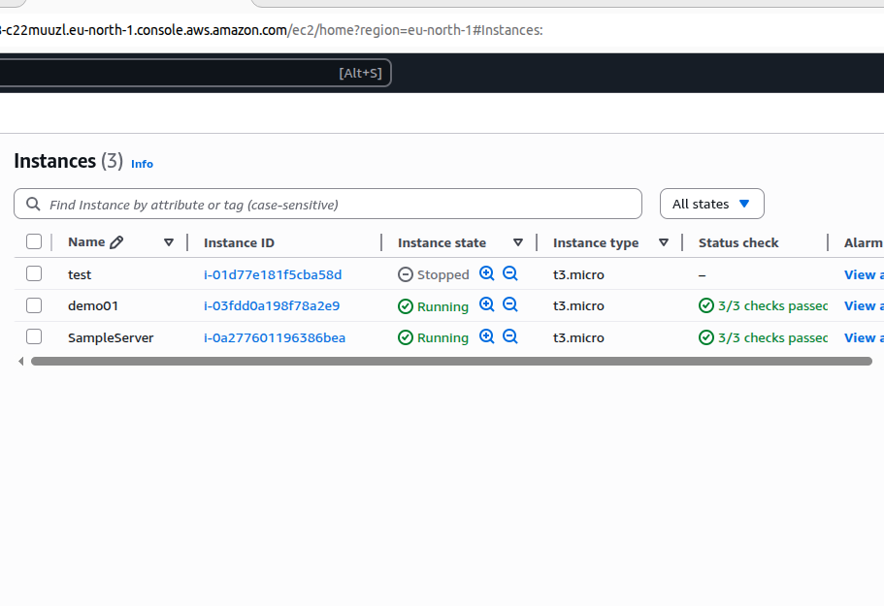

  - to destroy resouces (ec2) – terraform destroy
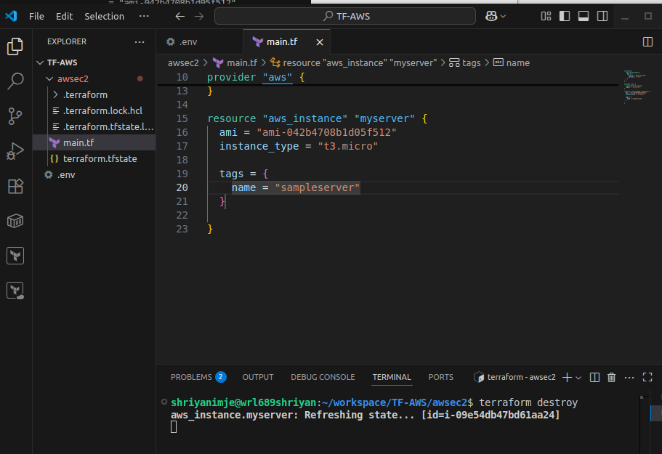

Working with Variable
  - creating a variable is main.tf.
  - creating region as a Variable and proiving some values to it.(description,type,default region)
  - Configured the AWS Provider Block.
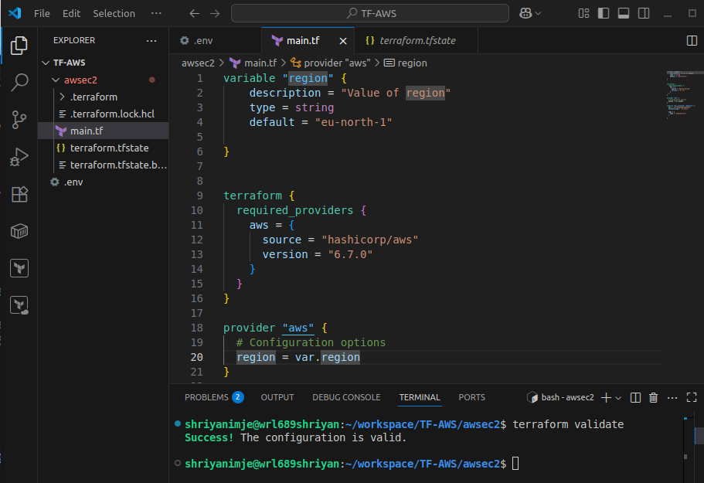

  - By using variable.tf file
  - Create variable.tf file within the same folder.
  - Creating variable – region and configuring it in main.tf
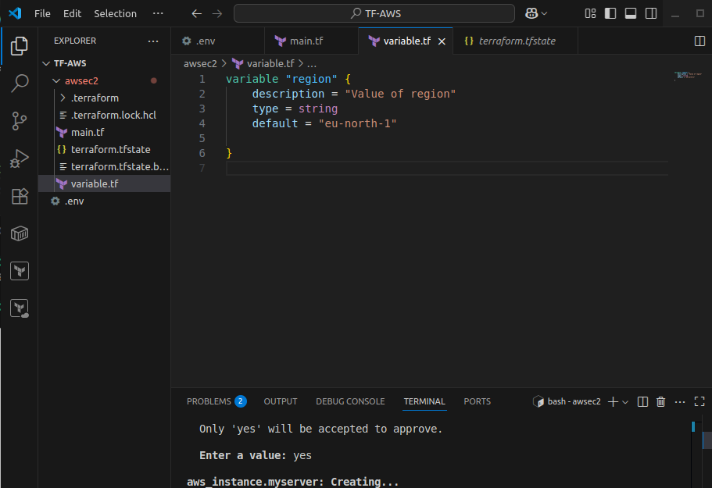

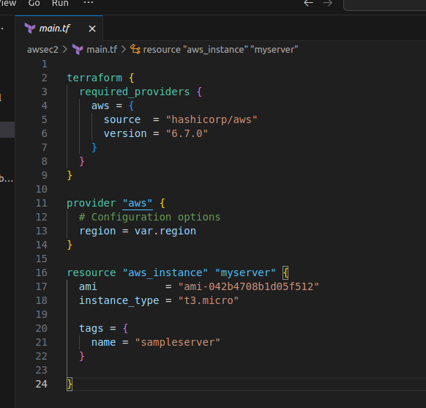

Working with output
  - create output.tf file to print the public ip of ec2
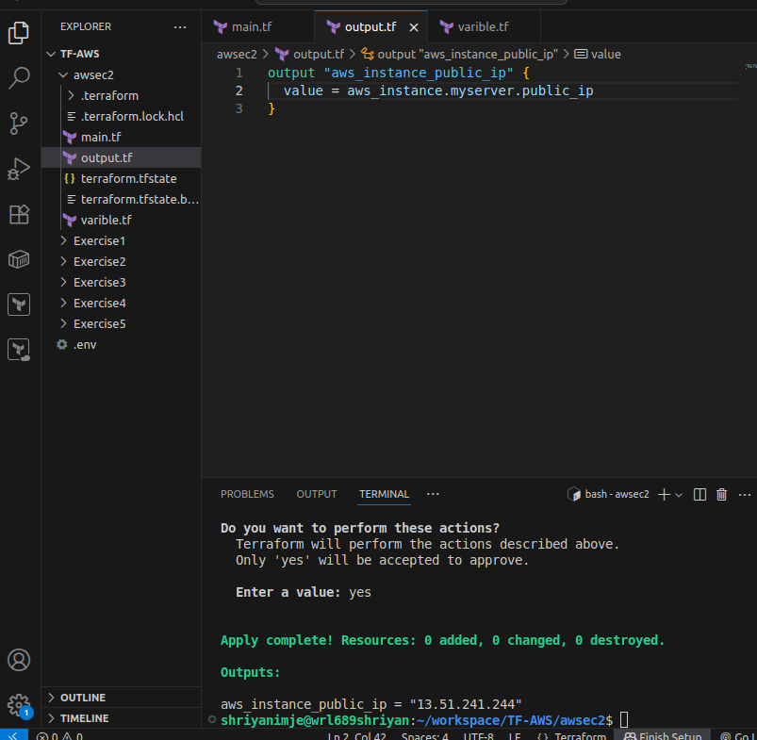

- Working with S3
  - Creating a S3 bucket – tera004
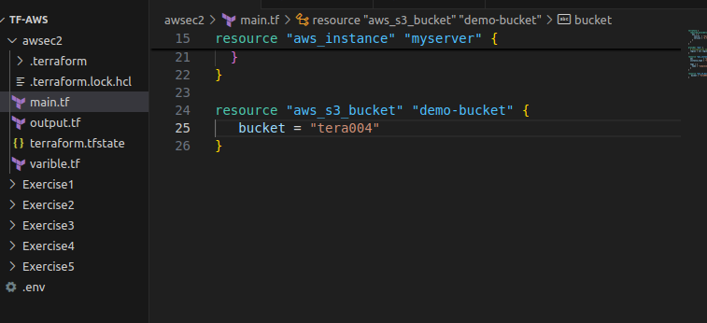

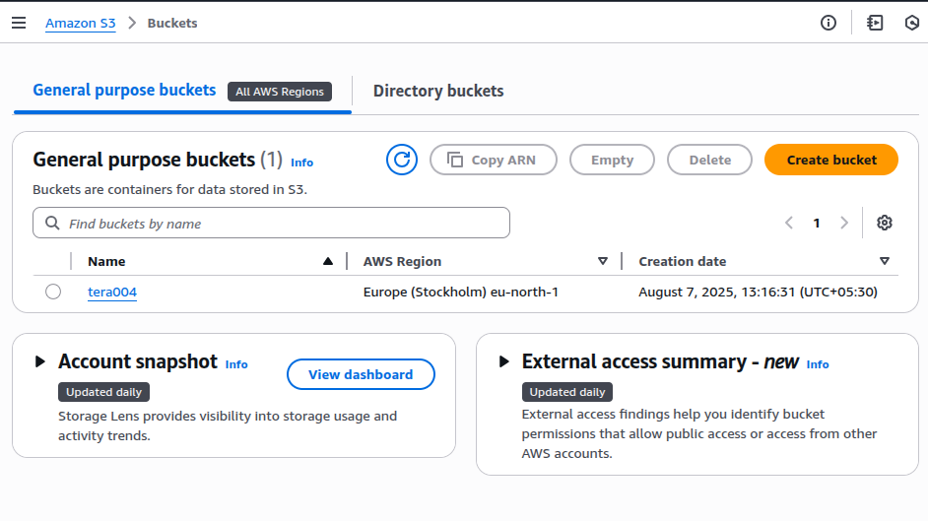

  - using tera004 to backup
  - creating a backend.tf to configure the backup of terraform.statetf
